Data Flow Diagram and User Stories

# DFD Level 0

The DFD Level 0 shows interaction between user, UI, backend model, and output system.

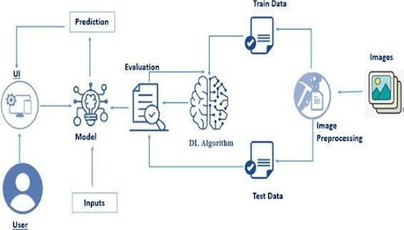

Figure 1: DFD Level 0 of Smart Sorting

# User Stories

|  |  |  |  |  |  |
| --- | --- | --- | --- | --- | --- |
| User Type | User Story | Story ID | Task | Acceptance Criteria | Priority |
| Factory Worker | Upload and analyze produce | US-01 | As a user, I can upload an image to receive freshness feedback. | System returns correct prediction. | High |
| Admin | Model monitoring and feedback | US-02 | As an admin, I can review incorrect predictions for improvement. | Feedback mechanism works. | Medium |